LGET 433

Mid-term Exam

Spring 2016

1. Log onto the IBM Mainframe. Use function 3.3 to make a copy of SHARE.GET433.COBOL(SU##PGMT) in your COBOL source library. Change all ## to your RACF-id numbers. Compile the program (changes will be needed).

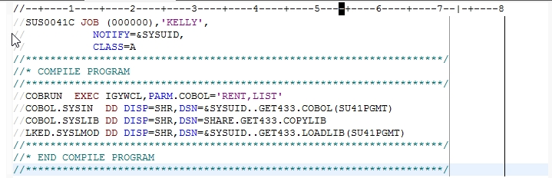

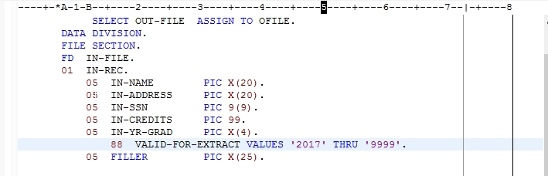

Also, change the logic to extract all records having a year of graduation greater than 2016.

Provide screen shots of the compile and the logic change.

2. For each of the following, determine the number of bytes reserved in the WORKING-STORAGE SECTION:

a. PIC X(13) VALUE SPACES. 13

b. PIC S9(9) VALUE 0. 9

c. PIC 9(4) COMP. 32

d. PIC 9(7) COMP-3. 4

e. 01 FILLER. 19

05 FLDA PIC X(3).

05 FLDB PIC X(16).

3. In what section and division of a COBOL program would you likely store counters and switches? Describe the use of 88 levels in storage for a COBOL program.

Environment Division in the Working-storage section.

The 88 levels are used to work in the logic of the program with the if statement.

4. What are the advantages and disadvantages of using a VSAM indexed file as input into a VSAM program?

A search in a vsam file is processed faster than in a sequential file, there are no splits or fragmentation.

The vsam files require to set the index, metadata and the data in a different JCL.

7. What is the largest number that you can put into a PIC 9(4) COMP field?

4294967296

8. If you move 125987V15 to an edited field PIC $$,$$$,$$9.99 - provide the results that you would expect to see on a printed page.

$,125,987.15

11. What is a return code (VSAM) or a RESPONSE?

14. What does the "AT END" statement do when reading a sequential file.

It reads a mark in the end of the file and the programmer can know where is the end of file.